**PNEUMONIA CANDIDA GLABRATA DI PASIEN PASKA COVID-19: LAPORAN KASUS**

***Jahja Teguh Widjaja1 Evelyn Nathania2***

*1 Departemen Pulmonologi, Universitas Kristen Maranatha, RS Immanuel Bandung*

*1 General Practitioner, RS Immanuel Bandung*

***Abstrak***

***Latar belakang:*** *Salah satu masalah yang timbul di pasien pasca COVID-19 adalah infeksi sekunder dan infeksi jamur merupakan salah satu masalah yang harus kita deteksi sedini dan semaksimal mungkin. Seringkali kita salah mendiagnosis bahkan menatalaksana dengan tidak baik. Candida glabrata adalah salah satu pathogen di infeksi jamur yang tergolong langkan dan bisa beraksi sebagi agen infeksius pada indicidu dengan daya tahan tubuh yang kurang*

***Kasus:*** *Wanita, 69 tahun datang dengan kelihan batuk dan sesak selama lima ari. Riwayat positif COVID-19, sudah diberikan pengobatan dan pulang dengan negative tes swab PCR untuk COVID-19. Setelah pulang, dia melakukan beberapa tes X-Ray dada dengan keluhan batuk yang semakin parah. Kultur sputum menunjukkan positif untuk Candida glabrata dan negative untuk BTA. Dia mendapat anti-fungal dan kondisinya menjadi lebih baik dengan gambaran X-Ray dada yang menunjukkan inflitrat yang semakin sedikit*

***Diskusi:*** *COVID-19 sendiri menjadi factor risiko terjadinya infeksi sekunder karena disregulasi sisem imun yang disebabkannya. Penggunaan antibiotic spektrum luas, kondisi sistem imun pasien, dan penggunaan alat medis adalah factor risiko terjadinya infeksi Candiada. Sementara itu, Candida galbrata tergolong jarang namun tetap harus kita perhatikan.*

***Kesimpulan:*** *Kita semia tahu bahwa COVID-19 mempengaruhi berbagai macam aspek kehidupan meskipun telah ditatalaksana. Beberapa pasien bisa mengeluhkan berbagai macam gejala setelah infeksinya.Infeksi jamur terutama Candida susah untuk didiagnosis dan memiliki mortalitas yang tinggi. Meskipun Candida Glabrata lebih jarang daripada C.Albicans, namun memiliki tantangan dalam menatalaksana dan mendiagnosisnya.*

***Kata kunci:*** *Candida;Glabrata;Pneumonia;Post COVID-19*

***CANDIDA GLABRATA PNEUMONIA IN POST COVID-19 PATIENT:***

***A RARE CASE REPORT***

***Jahja Teguh Widjaja1 Evelyn Nathania2***

***Abstract***

***Background:*** *One of the issues in post COVID-19 is secondary infection and fungal infection is one of the secondary infections we should recognise early and properly****.*** *It is often underdiagnosed and undertreatment. Candida glabrata as one of the pathogens in fungal infection is rare and can acts as infectious agent with individuals in reduced immunity*

***Case:*** *A 69-year-old man came to hospital with major complaints of cough and shortness of breath for five days. He was being positive for COVID-19, received treatments and being discharged after negative in PCR swab test for COVID-19. After being discharged, he did several chest X-ray examinations with progressively worsening cough. His sputum culture was positive for Candida glabrata and negative for BTA. He received anti-fungal treatment and his condition was getting better and chest X-ray showed less infiltrates.*

***Discussion:*** *COVID-19 itself carries a risk for secondary infection because its dysregulation in immune system.**The use of broad-spectrum antibiotics, immune-suppression of the host, and use of medical devices are major risk factors for Candida infections. Meanwhile C. Albicans is still the most common cause of fungal pneumonia by Candida, we should consider C. glabrata as one of its pathogens*

***Conclusion:*** *We all know that COVID-19 affects many aspects in our life, even after we treat the main problem, some patients can occur symptoms after. Fungal infection especially invasive candidiasis is hard to diagnose and have high mortality. Although C. glabrata is rarer than C. albicans, it has its own problem and hard to treat too.*

***Keywords:*** *Candida; Glabrata; Pneumonia; Post COVID-19*

**Korespondensi:** Evelyn Nathania

**Email:** [evelynlogamarta@gmail.com](mailto:evelynlogamarta@gmail.com)**; Hp:** 089676377000

**BACKGROUND**

Severe Acute Respiratory Syndrome (SARS-CoV2) caused by coronavirus has been declared by WHO as global pandemic since March 2020 and affects many aspects in life (1). It can develop into post COVID-19 problems, which means people suffering from symptoms after SARS-CoV2 infection, and it had been an issue we all have to face(2).

Secondary infection in post COVID-19 is a problem with high mortality (56,7%) and often underdiagnosed especially fungal infection(3). COVID-19 carries a risk of developing secondary infection and we as health practitioner should recognise and treat it properly. *Candida* species rarely cause pneumonia with the most common pathogen among the *Candida* species is C. *albicans*. C. *glabrat*a is known as non-pathogen *Candida* species and rarely acts as infectious agent but it can present in individuals with reduced Immunity(4). This case is about post COVID-19 patient with Candida *glabrata* pneumonia.

**CASE**

A 69 years old man came to our hospital with cough as main complaints. He had progressively worsened purulent cough in the last 4 days. He also complained shortness of breath with fever and myalgia.

His medical history was being positive for COVID-19 (swab PCR tested positive) 1 month before. Being isolated in home, but he had dyspnoea few days later and went to hospital. His chest X-Ray showed bilateral infiltrates (figure 1) and he had treatment for 9 days. One day after being discharged, he had cough, fever and his saturation dropped on 90-91%. His chest X-Ray showed more infiltrates than before (figure 3), had treatments for 8 days and discharged with negative swab PCR test for COVID-19. Five days later, he developed symptoms like we described above, had chest X-Ray (figure 4) and came to our hospital. He also had diabetes mellitus type II and no previous history of tuberculosis.

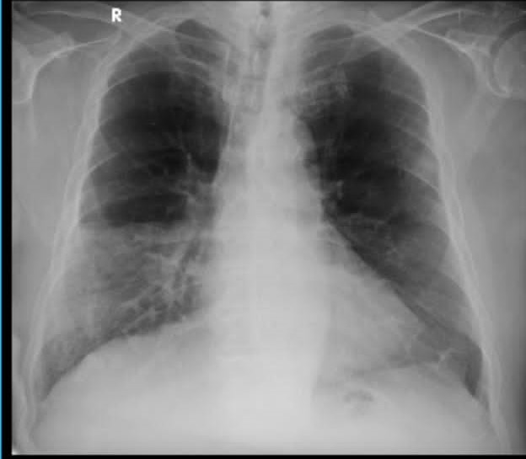

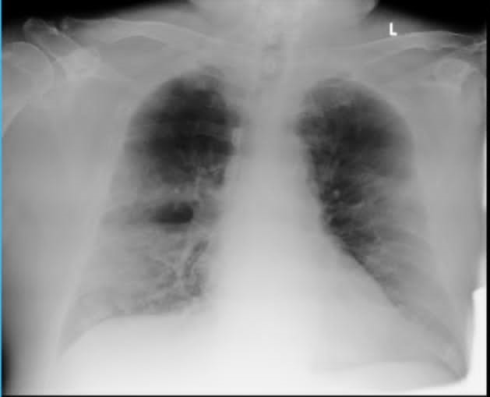Figure 1. Chest X-Ray when he first admitted for being positive for COVID-19

Figure 2. Chest X-Ray when he was being discharged for being positive for COVID-19 (day 8 admission in hospital)

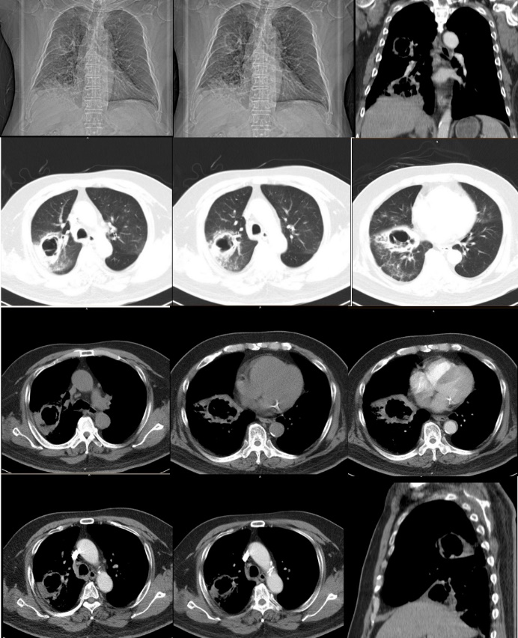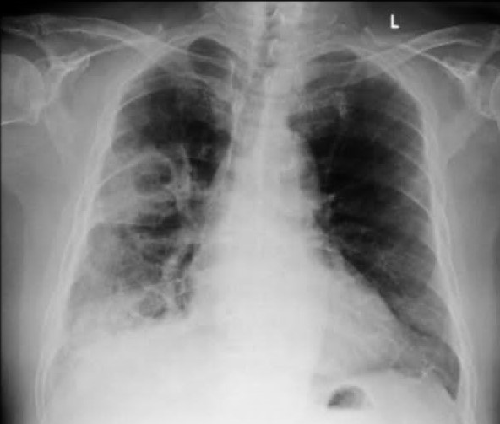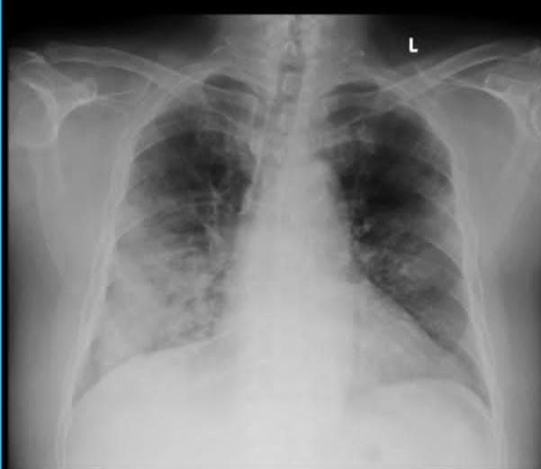Figure 3. Chest X-Ray on his second admission into hospital

Figure 4. Chest X-Ray on current state, showed areas of consolidation with cavitation in right mid and lower lobes

Physical examination revealed blood pressure of 130/70 mmHg and pulse of 97/minute, temperature was 37,8∘ Celsius, and finger-tip measured oxygen saturation (SpO2) was 92% on room air with respiration rate 26/minute. Rales were present on auscultation on mid and lower zones of right lung. He showed no oral candida and showed no respond on antibiotics (based on his previous prescription). Laboratory investigation showed leucocytosis with WBC count of 11.8/mm3 and negative Swab PCR Test for COVID-19. On third day of admission, he had chest CT-Scan (Figure 5) showed nodule with irregular wall thickening and cavitation (doughnut sign) on upper and mid right lung with suggestive fungi infection with differential diagnosis lung tuberculosis. He also had sputum test for BTA and negative two times and negative molecular test for MTB. His sputum culture was positive for Candida *galbrata* (*C.galbrata*)*.* He started anti-fungal and getting better after. His symptoms were better and his vital sign was stable, his followed-up chest x-ray showed less infiltrates (figure 6,figure 7 and figure 8). He was allowed to discharged from hospital and did some follow up tretments.

Figure 5. Chest CT-Scan

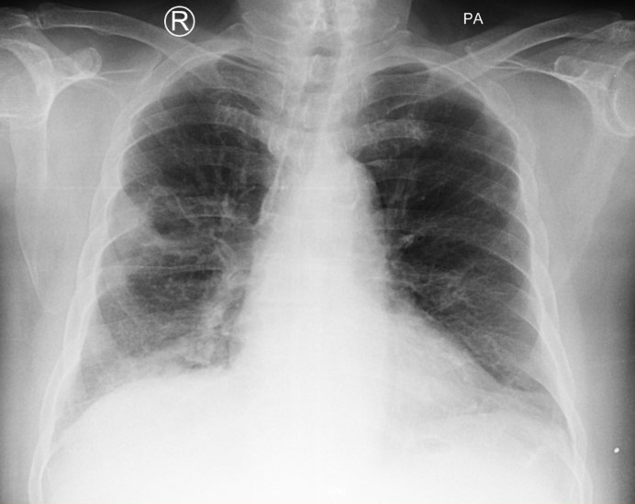

Figure 6. Chest X-Ray on our hospital admission day 8 and on anti-fungal treatment day 4, showed less infiltrates than before

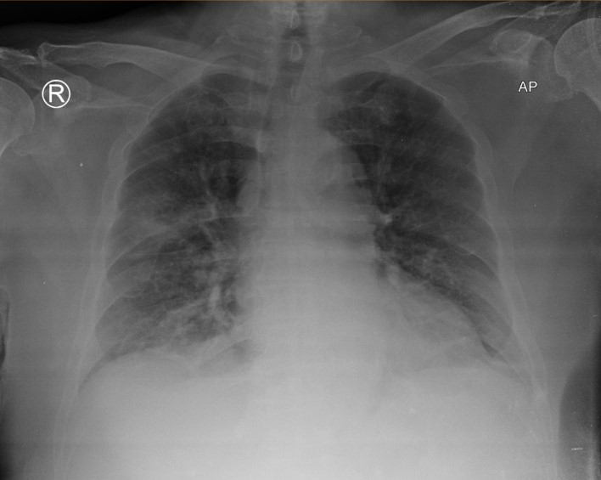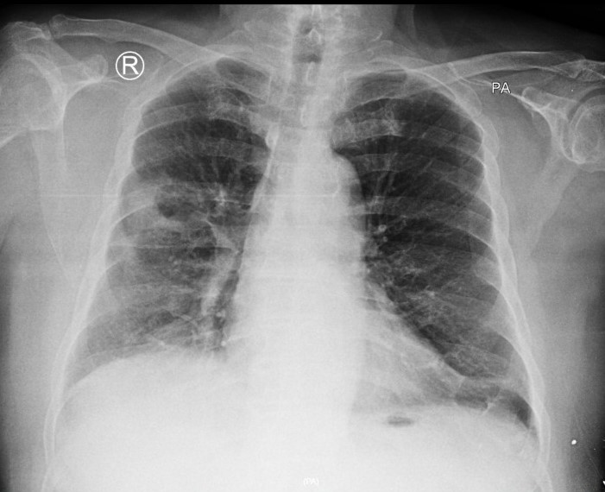Figure 7. Chest X-Ray before hospital discharged and on last day anti-fungal treatment, showed less infiltrate on lower right lobe

Figure 8. Chest X-Ray Followed up on clinic, one week after discharged

**DISCUSSION**

Severe Acute Respiratory Syndrome (SARS-CoV2) infection cause many problems and affects many aspects in life. Even after being treated, it still has effects and symptoms on population. Researchers and several studies have reported the use of long-term complications of COVID-19 with a variety of symptoms and organ-related injuries, which has been referred to as “long COVID” or “post-acute COVID-19 syndrome”.(5) Post COVID-19 is condition to describe health issues that persists more than four months after first being infected with the virus. Most people with COVID-19 get better within weeks to months of illness, but some do not(6). Even we treat the main infection, the massive number of people who have been infected with SARS-CoV-2 suggests that this will represent a public health issue leading to a major consumption of healthcare resources. The issue of long COVID has been identified as a clear priority of the utmost importance for the World Health Organization(7).

One of the issues in post COVID-19 is secondary infection and fungal infection is one of the secondary infections we should recognise early and properly. Immunosuppressed patients, like COVID-19 patients especially with comorbid like diabetes mellitus, fungal respiratory infections generate special concern.It is often underdiagnosed and late in treating it and increase its mortality. Fungi may colonize body sites without producing disease or they may be a true pathogen, generating a broad variety of clinical syndromes.Fungal pneumonia is an infectious process in the lungs caused by one or more endemic or opportunistic fungi. From studies, the main fungal pathogens for fungal coinfections in severe COVID-19 are *Aspergillus* and *Candida*. Other infrequent opportunistic pathogenic fungus caused lung infections also need to be considered, such as *Mucor* and *Cryptococcus*. Opportunistic fungal organisms like we mentioned before, tend to cause pneumonia in patients with congenital or acquired defects in the host immune defences such as COVID-19 patients.(8,9)

The recent global pandemic of COVID-19 has predisposed a relatively high number of patients to acute respiratory distress syndrome (ARDS), which carries a risk to develop super-infections and COVID-19 made a dysregulation in immune system. *Candida* species are major constituents of the human mycobiome and non-pathogen if the host immune is normal and it is inhabiting various mucosal surfaces. Although being commensal within the human host, *Candida* species are equipped with virulence attributes, enabling them to invade when opportunities arise and cause various infections in humans, especially when the immune system is impaired. The most prevalent *Candida* species as per the recent studies COVID-19 patients, is *Candida albicans* (44.1%); followed by *C. auris* (23.2%); *C.glabrata*, *C. parapsilosis*, *C.tropicalis*, and *S. cerevisiae* (4.6% each); and *C.krusei* and *Rhodotorula spp*. (2.3% each). Candida infection is rare, meanwhile the estimated mortality attributed to invasive candidiasis is 19-40% (10,11).

The use of broad-spectrum antibiotics, immune-suppression of the host, and the use of medical devices are major risk factors for *Candida* infections. Meanwhile *C. Albicans* is still the most common cause of fungal pneumonia by *Candida*, non-*C. albicans* species has increased over the years and need more attention. *C. glabrata* is the second or third most frequently isolated *Candida* species. This high incidence can be partially explained by the inherent low susceptibility of *C. glabrata* to the most used class of antifungal drugs, the azoles, and consequently *C. glabrata* are associated with high mortality rates. Invasion of the pulmonary parenchyma by Candida is rare, due to which its presence in respiratory specimens is usually regarded as contamination, however, with the increased use of immunosuppressive agents, mucosal and systemic infections caused by *C. glabrata* have increased significantly, especially in the human immunodeficiency virus-infected population (12,13). The wide usage of antibiotics, steroids, along with insult by SARS CoV-2 infection, causes commensal *Candida* to invade internal organs. When *Candida* enters the blood and spreads to other body sites, there occurs Invasive candidiasis. The various predisposing factors include immunosuppression, surgical procedures, renal failure, prolonged placement of central venous catheter, malignancy, prolonged antibiotic usage, late sepsis. Fear of missing a secondary infection and lack of specific therapy for COVID-19 leads to over-prescription of antibiotics. Sending appropriate cultures, use of biomarkers like procalcitonin and galactomannan and antibiotic time-out at 48 hours of prescription can help in reducing unnecessary antibiotic prescriptions (3,14). Awareness of the possibility of fungal co-infection

is essential to reduce delays in diagnosis and treatment in order to help prevent severe illness and death from these infections (15).

In this patient, we see COVID-19 carries its own risk as major risk factor for Candida infection along with his diabetes mellitus as his comorbid. It made host immune system became impermeable. The use of antibiotics before also came as a risk factor because usually, the secondary infection of COVID-19 is bacterial infection. Cavitary pneumonia presentation of pulmonary candidiasis is rare but was seen in the present case and chest X-Ray. We diagnosed this case as invasive candidiasis by the patient’s clinical futures, positive sputum cultures, Chest X-Ray and chest CT-Scan. Although we also think about differential diagnosis such as tuberculosis infection that closely have the same clinical presentations and Chest X-Ray figures but he was negative for BTA sputum two times along negative in sputum molecular test for MTB. After given anti-fungal treatment, his condition was getting better and he showed less infiltrates and cavitation in his follow-up chest X-Ray.

We as health practitioner should aware that COVID-19 can develop secondary infection even after we treat the main COVID-19. When it is developing into secondary infection, it is hard to diagnose the etiologic and relies on a combination of clinical, radiologic, and microbiological factors(9). COVID-19 itself is a risk factor, furthermore there are other risk factors besides immunosuppression condition made by COVID-19 like the use of broad-spectrum antibiotics and host immune status and patients comorbid. Antibiotics should be given wisely and think about the benefits and the risks. Diagnosis and prompt treatment should be delivered quickly, especially when the patient gets candidiasis as secondary infection because it has high mortality.

**CONCLUSION**

We all know that COVID-19 affects many aspects in our life, even after we treat the main problem, some patients can occur symptoms after it. Fungal infection especially invasive candidiasis is hard to diagnose and have high mortality. We as health practitioner should consider host immune status, comorbid such diabetes mellitus, diagnose it quickly, and perform tests and cultures to treat it properly. Although *C. glabrata* is rarer than *C. albicans,* it has its own problem and hard to treat too.

**REFERENCE**

1. Cennimo DJ. Coronavirus Disease 2019 (COVID-19) [Internet]. Medscape. 2021. Available from: https://emedicine.medscape.com/article/2500114-overview

2. Fernández-De-las-peñas C, Palacios-Ceña D, Gómez-Mayordomo V, Cuadrado ML, Florencio LL. Defining post-covid symptoms (Post-acute covid, long covid, persistent post-covid): An integrative classification. Int J Environ Res Public Health. 2021;18(5):1–9.

3. Vijay S, Bansal N, Rao BK, Veeraraghavan B, Rodrigues C, Wattal C, et al. Secondary infections in hospitalized COVID-19 patients: Indian experience. Infect Drug Resist. 2021;14:1893–903.

4. Yazici O, Cortuk M, Casim H, Cetinkaya E, Mert A, Benli AR. Candida glabrata Pneumonia in a Patient with Chronic Obstructive Pulmonary Disease . Case Rep Infect Dis. 2016;2016:1–4.

5. Al-Hatmi Abdullah M.S.; Jalila Mohsin;Aisha Al-Huraizi;Faryal Khamis. COVID-19 Assosiated Invasive Candidiasis. J Infect. 2020;82(January 2021):2020–2.

6. Aiyegbusi OL, Hughes SE, Turner G, Rivera SC, McMullan C, Chandan JS, et al. Symptoms, complications and management of long COVID: a review. J R Soc Med. 2021;0(June):1–15.

7. Lansbury L, Lim B, Baskaran V, Lim WS. Co-Infections in People with COVID-19: A Systematic Review and Meta-Analysis. SSRN Electron J. 2020;(January).

8. Song G, Liang G, Liu W. Fungal Co-infections Associated with Global COVID-19 Pandemic: A Clinical and Diagnostic Perspective from China. Mycopathologia [Internet]. 2020;185(4):599–606. Available from: https://doi.org/10.1007/s11046-020-00462-9

9. Mandanas RA. Fungal Pneumonia [Internet]. Medscape. 2019. Available from: https://emedicine.medscape.com/article/300341-overview

10. Rolling T, Hohl TM, Zhai B. Minority report: the intestinal mycobiota in systemic infections. Curr Opin Microbiol [Internet]. 2020;56(September):1–6. Available from: https://doi.org/10.1016/j.mib.2020.05.004

11. Pemán J, Ruiz-gaitán A, García-vidal C, Salavert M. Fungal co-infection in COVID-19 patients: Should we be concerned? 2020;(January).

12. Timmermans B, Peñas AD Las, Castaño I, Van Dijck P. Adhesins in candida glabrata. J Fungi. 2018;4(2):1–16.

13. Kaur H. Invasive Candidiasis with Cavitary Lung Lesion in a Post-Covid-19 Diabetic Patient- A Case Report. J Clin Med Res. 2021;3(5):1–6.

14. Balasopoulou A, Κokkinos P, Pagoulatos D, Plotas P, Makri OE, Georgakopoulos CD, et al. Symposium Recent advances and challenges in the management of retinoblastoma Globe ‑ saving Treatments. BMC Ophthalmol [Internet]. 2017;17(1):1. Available from: http://www.ncbi.nlm.nih.gov/pubmed/28331284%0Ahttp://www.pubmedcentral.nih.gov/articlerender.fcgi?artid=PMC5354527%5Cnhttp://bmcpsychiatry.biomedcentral.com/articles/10.1186/1471-244X-11-49%5Cnhttp://bmcophthalmol.biomedcentral.com/articles/10.1186/s12886

15. Didbaridze T, Ratiani L, Labadze N, Maziashvili T, Didbaridze N, Gogokhia N. Prevalence and Prognosis of Candidiasis among Covid-19 Patients : Data from ICU Department. Int J Progress Sci Technol [Internet]. 2021;26(1):36–9. Available from: http://dx.doi.org/10.52155/ijpsat.v26.1.2940