**Anatomical Pathology Differences in Lung Alveoli Damage with Exposure to Conventional Cigarette and Electric**

***Citra Paramita Esti Cahyaningrum1* *Desy Andari2* *Djoni Djunaedi3***

*1 Undergraduate Student of the Faculty of Medicine, University of Muhammadiyah Malang, Malang*

*2 Department of Histology, Faculty of Medicine, University of Muhammadiyah Malang, Malang*

*3 Department of Internal Medicine, Faculty of Medicine, University of Muhammadiyah Malang, Malang*

***Abstrak***

***Latar belakang:*** *Pada rokok konvensional, tembakau merupakan faktor resiko utama dalam perkembangan penyakit yang melibatkan paru – paru, termasuk emfisema, fibrosis dan kanker. Kemudian banyak orang yang beranggapan bahwa menggunakan rokok elektrik jauh lebih aman dibandingkan rokok konvensional. Padahal merokok dengan menggunakan rokok elektronik dapat menimbulkan perasaan yang sama dari cotton mouth seperti yang dirasakan oleh perokok konvensional dengan gejala seperti tenggorokan gatal dan batuk serta menimbulkan komplikasi ke paru-paru.*

***Metode:*** *Kajian pustaka ini menggunakan metode literature review dengan kata kunci cigarette, e-cigarette, popcorn lung dan alveoli.*

***Hasil:*** *Didapatkan hasil yang sesuai dengan tujuan kajian pustaka ini. Hasil analisis menunjukkan terdapat penelitian yang menyatakan bahwa merokok dengan rokok konvensional dan rokok elektrik dapat memberikan dampak terhadap kerusakan alveoli dan jaringan paru.*

***Kesimpulan:*** *Rokok konvensional dan rokok elektronik (e-cigarette) menyebabkan kerusakan alveoli paru berupa pembesaran ruang alveolar, hal ini tergantung pada kadar kandungan nikotin di dalamnya.* *Rokok elektronik dan rokok konvensional memberikan efek yang berbeda pada respon stress oksidatif epitel jalan nafas. Selain itu, gambaran popcorn lung bisa ditemukan akibat adanya diacetyl yang muncul saat pemanasan e-juices pada rokok elektrik.*

***Kata kunci:*** *cigarette, e-cigarette, popcorn lung, alveoli.*

***Anatomical Pathology Differences in Lung Alveoli Damage with Exposure to Conventional Cigarette and Electric***

***Abstract***

***Background:*** *In conventional cigarettes, tobacco is a major risk factor in the development of diseases involving the lungs, including pulmonary emphysema, fibrosis and lung cancer. Many of people think that using e-cigarettes is much safer than conventional cigarettes. Whereas smoking using electronic cigarettes can cause the same feeling from cotton mouth as felt by conventional smokers with symptoms such as an itchy throat and cough and complications to the lungs.*

***Methods:*** *This literature review uses the literature review method by conducting a literature with the keywords cigarette, e-cigarette, popcorn lung and alveoli.*

***Results:*** *The results are in accordance with the objectives of this literature review. The results of the analysis show that there are studies which state that smoking with conventional cigarettes and e-cigarettes can have an impact on damage to alveoli and lung tissue.*

***Conclusion:*** *Conventional cigarettes and electronic cigarettes (e-cigarettes) cause damage to the pulmonary alveoli in the form of alveolar spaces, this depends on the nicotine content in them. Electronic cigarettes and conventional cigarettes exert different effects on the oxidative stress response of the airway epithelium. In addition, the image of popcorn lung can be found due to the presence of diacetyl that appears when heating e-juices in e-cigarettes.*

***Keywords:*** *cigarette, e-cigarette, popcorn lung, alveoli*

**Korespondensi: Citra Paramita Esti Cahyaningrum**

**Email:** citraparamiiita@gmail.com **; Hp:** 081233937318

**INTRODUCTION**

Based data from RISKESDAS 2018, shows that the national average of smokers aged over 15 years is 32.2% and almost 50% of provinces show numbers above the national average. The increase in the number of businesses from 2013 to 2018 was 0.7% at the age of 10-14 years and 1.4% at the age of 15-19 years (1).

Indonesia has a proportion of the population that consumes tobacco (sucking and chewing) in 2018 of 62.9% for men and 4.8% for women. These data indicate that the number of male smokers in Indonesia is higher than that of women and these data indicate that the number of smokers in Indonesia is higher than that of non-smokers (1).

In addition to tobacco smokers, in Indonesia, there are also many users of e-cigarettes. It was recorded that in 2018 the national average prevalence of electronic cigarette users in Indonesia reached 2.8%. Although the number of tobacco smokers has increased, e-cigarette users are recorded in 13 provinces above the national average prevalence. Most of the areas that have the highest prevalence of e-cigarette users are on the island of Java (1).

Many people think that e-cigarettes are safer than conventional cigarettes. Recent infographic data reveal that smoking using e-cigarettes can elicit the same feelings from a cottonmouth as conventional smokers with symptoms such as an itchy throat and cough. Electronic cigarettes can cause complications to the lungs. Smoking using electronic cigarettes (Vaping) can cause serious damage to these organs (17).

Chemicals in e-cigarettes can damage lung tissue by triggering inflammation. The damage can reduce the ability of the lungs to prevent infection with germs and other harmful substances, whereas in tobacco cigarettes and e-cigarettes, according to the U.S. The Food and Drug Administration says that nicotine is harmful to adolescent brain development. Although there is a liquid in electronic cigarettes that do not contain nicotine, the use of e-cigarettes can interfere with the function of the lungs (18).

Vaping of propylene glycol and glycerol aerosols at high doses and in large amounts has been shown to cause sustained impaired gas exchange and lower respiratory tract epithelial injury. Previous investigations revealed sequelae and abnormalities on radiographs and pulmonary function tests at a later date (2). In conventional cigarettes, tobacco is a major risk factor in the development of diseases involving the lungs, including pulmonary emphysema, fibrosis, and lung cancer (3).

Based on the explanation of the background above, the researcher wants to know and prove that consuming electronic cigarettes and conventional cigarettes can trigger damage to the alveoli and tissues in the human lungs.

**METHODS**

This literature review uses the literature review method by conducting a literature review of 27 journals and 7 textbooks. Journals were obtained from PubMed, Elsevier and Google Scholar searches with the keywords cigarette, e-cigarette, popcorn lung, and alveoli which were selected with the criteria of national journals accredited by Sinta and international journals with a good reputation and indexed by Scopus and non-scopus. The study was conducted by interpreting and identifying previous studies related to the anatomical pathology of the alveoli exposed to conventional cigarette smoke and e-cigarettes.

**RESULT**

In a study conducted by Andrault et al (2019), in this study discusses the induction of cigarette smoke on the overexpression of active Cathepsin s in human lungs.

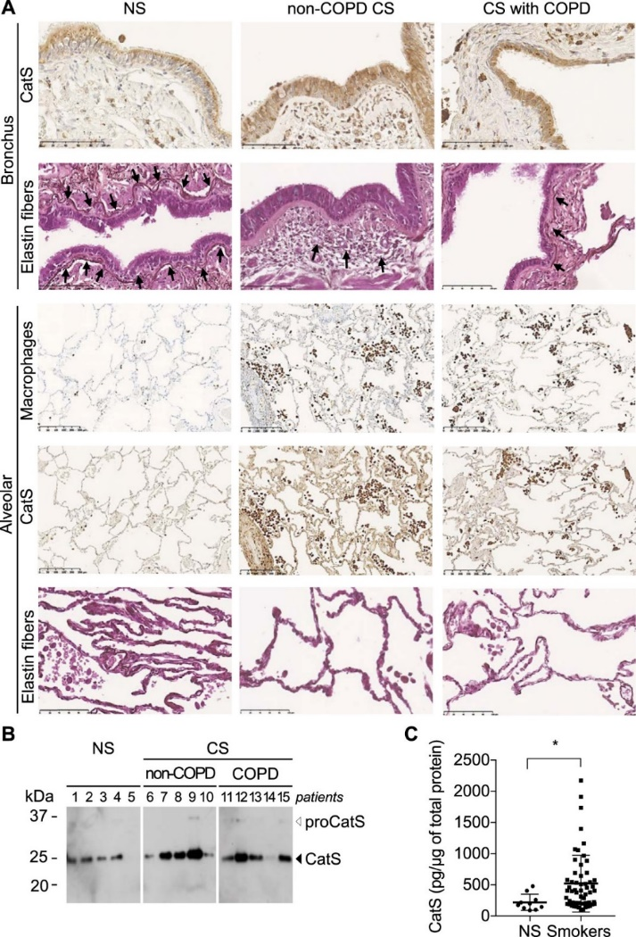

(7)

Figure 1 Expression of Cathepsin S protein in peripheral lung tissue from non-smokers and smokers. Representation of histology sections of the bronchial and alveolar epithelium. Elastin Fiber is indicated by a pointing arrow.

Simple levels of immunoreactive CatS were observed in non smokers (NS) lungs, while higher expression of CatS was readily detectable in non-COPD current smokers (CS) and CS with COPD. In this study, the highest CatS expression was observed in bronchial epithelial lining, type II pneumocytes, and alveolar macrophages. CatS immunoreactivity was also detected in the submucosal glands, whereas the non-ciliated club cells of the bronchiolar epithelium stained weakly. The important factor in the pathogenesis of cigarette smoke-induced emphysema is degradation of the pulmonary interstitium by elastinolytic proteases including CatS. Accordingly, more areas of disruption and fragmentation of elastin fibers in lung tissue from non-COPD CS and CS with COPD compared to NS were observed.

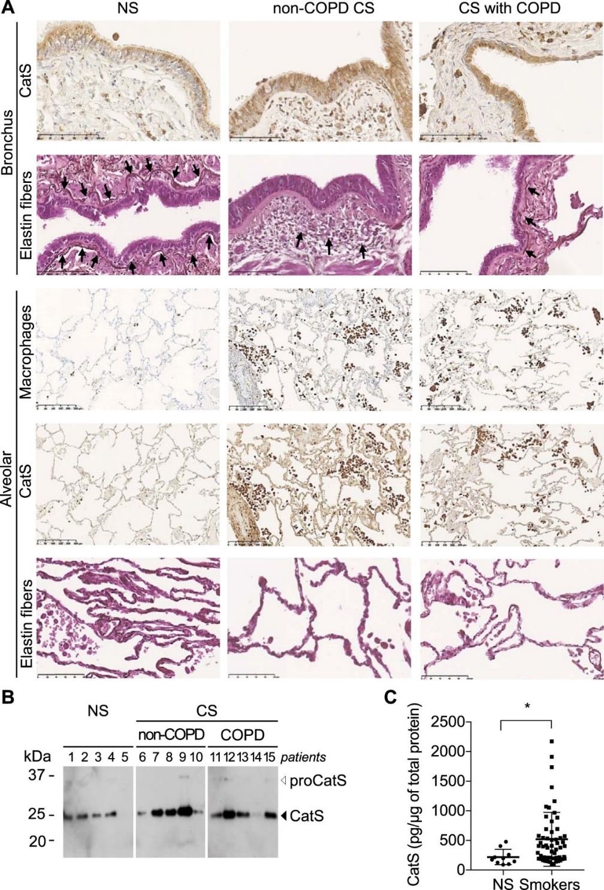

(7)

Figure 2 Western blot representation of mature CatS in pulmonary peripheral tissue lysates

In figure 2 discusses Cathepsin S levels in lung tissue of never-smokers and smokers. Western-blot analysis confirmed a higher CatS protein expression in selected samples of non COPD and COPD smokers versus NS. The mature form of CatS (25 kDa) was strongly stained, the staining of its proform was fainter.



(7)

Figure 3 Total CatS expression evaluated by ELISA in lung tissue lysates

Moreover, the levels of immunoreactive CatS determined by ELISA was significantly ~2.5 fold higher in lung tissue lysates from the cohort of cigarette smokers compared to NS.

Table 1. Descriptive data on histopathological observations of widening, thickening, infiltration of the lumen, wall of alveolar lymphocytes

|  |  |  |  |
| --- | --- | --- | --- |
| Kn | 1 | 1 | 1 |
| E0 | 1 | 1 | 1 |
| E3 | 2 | 2 | 2 |
| Kv | 2 | 2 | 2 |

(Triantara, et al., 2019)

Treatment groups : Control (Kn), 0 mg nicotine (E0) e-cigarettes, 3 mg nicotine e-cigarettes (E3), and conventional cigarettes (Kv). Scoring: none (0), low (1), and large (2)

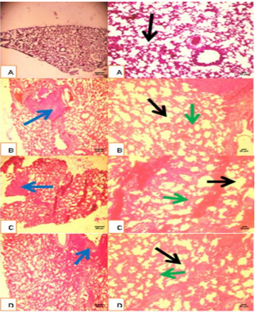

(11)

Figure 3 Micro photos with 40 times and 100 times magnification and with Hematoxylin-Eosin staining histopathological picture of the treatment group: A. Control (Kn), B. E-cigarette 0 mg nicotine (E0), C. E-cigarettes with 3 mg nicotine (E3), and D. Conventional cigarettes (Kv); E: thickening of the alveolar walls; F: lymphocytic infiltration; G: widening of the alveolus lumen

Triantara, et al, also conducted a study on the lung histopathology of white rats against exposure to conventional cigarettes and electronic cigarettes showing data as written in table 1 and figure 3. In this study, bronchial wall thickening, bronchial lumen dilation, and lymphocyte infiltration were assessed in the control animal group, e-cigarettes with 0 mg nicotine, e-cigarettes with 3 mg nicotine and conventional cigarettes (11).

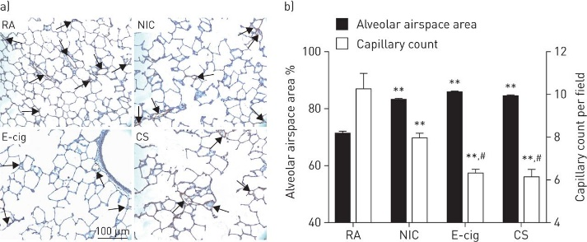

(4)

Figure 4 Effects of exposure to electronic cigarettes, nicotine and tobacco cigarettes on lung structure and number of blood vessels compared to room air. Figure a. Morphology and pulmonary vasculature (visualized

by staining for von Willebrand factor) after 5 days of exposure. The arrow in figure a shows the capillaries. Figure b. Enlargement of the alveolar air spaces.

Figure 4 shows the results as seen in emphysema patients, both airways and vascular cells are affected, resulting in enlargement of the alveolar air spaces and loss of peripheral blood vessels. So in this study it can be concluded that electronic cigarettes have the same toxic effect as tobacco cigarettes or conventional cigarettes and long-term exposure to nicotine vapor can cause significant lung damage (4).

**DISCUSSION**

In a study conducted by Reinikovaite, et al, (2017) in experimental mice, it was shown that the nicotine contained in electronic cigarettes is as harmful as conventional cigarettes to microcirculation. Exposure to the use of e-cigarettes or the production of nicotine has the same damaging effect as conventional cigarettes on the structure of the lungs and blood vessels (4).

Conventional cigarettes or tobacco cigarettes are known to cause damaging effects on the cardiovascular system, angiogenesis, skin capillary perfusion by causing direct injury to blood vessel walls, increasing platelet aggregation, microvascular thrombosis, and inflammation. Meanwhile, the consequences of exposure to e-cigarette vapor have not been widely explored (4).

Research conducted by Taylor, et al, (2016) showed that under comparable conditions when compared to conventional cigarettes, e-cigarettes did not activate the cellular stress response in an in vitro model of the airway epithelium (5).

Conventional cigarettes or tobacco cigarettes have an impact on the lungs by increasing the risk of lung cancer and also causing Chronic Obstructive Pulmonary Disease (COPD) which includes emphysema and chronic bronchitis (6). In addition, quoted from the research of Andrault, et al, (2019), tobacco cigarettes also induce overexpression of active cathepsin S in human lungs. Cathepsin S (CatS) itself is a cysteine ​​protease enzyme involved in the remodeling or degradation of connective tissue and basement membranes. CatS expression was found to be significantly higher in smokers (both with COPD and non-COPD) than in never-smokers (7).

In a study conducted by Zhang, et al, conventional cigarette smoke is also a strong risk factor for Idiopathic Pulmonary Fibrosis (IPF) and is a pro-senescent factor. Aging type II pneumocytes are involved in the pathogenesis of idiopathic pulmonary fibrosis (IPF) (19). In addition, smoking is known to cause emphysema which is known in the study conducted by Kosmider et al, (2019), which found high DNA damage and impaired DNA damage repair in mitochondria in type II pneumocyte cells isolated from emphysema patients contributing to mitochondrial dynamics. abnormal (8).

In a study conducted by Andrault et al, it was also found that exposure of human primary bronchial epithelial cells to cigarette smoke extracts triggers P2X7 receptor activation which can upregulate CatS. The highest expression of CatS was observed in bronchial epithelial layers, type II pneumocytes, and alveolar macrophages (7).

In emphysema, the walls of the air sacs (alveolar septa) appear to be destroyed and the air spaces (alveoli) become wider but irregular and reduced in number. This wider space results in less efficient gas exchange in the alveoli (21). In addition, emphysema found high levels of inflammatory cytokines such as IL8. It is known that the impact of smoking will produce IL6, IL10, and IL33 which increase the risk of lung cancer or other lung diseases (9). Along with the widening of the airway space, a reduction in peripheral blood vessels was found (4).

In emphysema shows the walls of the air sacs (alveolar septa) are destroyed. This situation interferes with the gas exchange of O2 and CO2. Alveoli are abnormal and protrude at the top for a complex reason. Figure 6 emphasizes that the blood vessels should not be mistaken for abnormal alveoli just because their shape is almost the same.

Cigarette smoke contains a lot of dirt particles that are inhaled in large quantities by the lungs. Therefore, the alveolar space of smokers contains many macrophage cells that are filled with particles as a result of the phagocytosis process (21).

Under a microscope with strong magnification, black and brown particles are seen that are phagocytized by macrophages. Smokers' lungs have so much of this particulate matter that the lungs look blackish gray. In addition, in a large prospective study of high-risk smokers, it was reported that there is a strong linear relationship between increased severity of airflow limitation and risk of lung cancer (10).

Triantara, et al research concluded that exposure to conventional cigarette smoke caused the greatest damage to the lungs of Rattus norvegicus based on alveolar macrophage and histopathological markers, but was not different from exposure to e-cigarette smoke with a concentration of 3 mg nicotine. E-cigarettes with a nicotine content of 0 mg can cause damage lower or equal to the control group based on histopathological markers (11).

According to Lerner, et al, (2015), in their research, it was stated that the vapor produced from electronic cigarettes and flavored e-juices can induce toxicity, oxidative stress, and inflammatory responses in bronchial airway epithelial cells (H292) and fetal lung fibroblasts (HFL1). ) in experimental animals. It is known that oxidative stress and inflammatory response are key events in the pathogenesis of chronic airway disease (12).

A study conducted by Reinikovaite, et al, (2017) measured the average alveolar air enlargement using an automated image analyzer software and calculated it as a percentage of total air space versus tissue density. Although less sensitive than stereological methods, measurement of the alveolar air space area accurately reflects changes in lung morphology (4).

In a study conducted by Taylor, et al, (2016) with comparable conditions when e-cigarettes were compared with conventional cigarettes, e-cigarettes did not activate the cell stress response in the airway epithelium(5).

E-cigarettes are known to contain harmful substances, including nicotine, vitamin E acetate, volatile organic compounds, heavy metals, ultra-fine particles, and carbonyl compounds. Of particular concern is the use of flavoring agents in e-liquids. There are more than 7700 e-liquid flavors across 60 brands. While many of these flavors are "generally recognized as safe" under the United States Federal Food, Drug, and Cosmetic Act, it's important to know that these only apply to consumption; aerosolization of safe-to-digest flavors can produce adverse health effects (13).

A cluster of cases of acute lung injury related to e-cigarette use have been reported since April 2019 across the United States. As of August 2019, more than 120 cases in at least 15 states have been identified. As of September 2019, more than 450 cases of vaping-related acute lung injury (EVALI) were reported to the CDC from 33 states across the country, including 7 deaths. In general, most of the previous patients were healthy adolescents, who experienced rapid onset of symptoms, including cough and severe dyspnea after vaping (14).

In e-cigarettes, data show that some flavorings can induce inflammation of the lungs. diacetyl-containing e-liquids such as caramel, butterscotch, watermelon, pina colada, and strawberries receive wide attention because they can cause bronchiolitis obliterans (popcorn lung) (9). The term popcorn lung has been given to another term for bronchitis obliterans because this disease usually occurs in popcorn factory workers who are exposed to butter-flavored volatiles, particularly diacetyl, which can impair lung epithelial barrier function (15). This diacetyl content is what causes popcorn lung symptoms in e-cigarette users.

Diacetyl and another flavoring agent, 2,3 pentanedione, can alter gene expression pathways associated with ciliary and cytoskeletal processes in normal human bronchial epithelial cells, and cause epithelial cell injury and bronchiolitis obliterans in mice. Inhaled diacetyl affects human cellular matrix remodeling and can stimulate fibroproliferative changes in the human airways (13).

Diacetyl has been identified in e-liquids at levels higher than the recommended safety limits, including in some products where the packaging clearly states that diacetyl is not an ingredient. One study found it in more than 60% of the e-cigarette flavor samples analyzed and another study showed that diacetyl is produced in e-liquids over time from another flavoring agent, acetoin. The chemical synthesis of diacetyl from acetoin is accelerated when nicotine is added to the vaping liquid, with the diacetyl concentration increasing over time. Vaping liquids stored for long periods can accumulate high levels of diacetyl which, when vaporized, can increase the risk of pulmonary toxicity (13).

The pathophysiology of bronchiolitis obliterans is inflammation of the sub-epithelial structures and repair of dysregulation in response to injury from inhaled toxins or an autoimmune response, leading to fibroproliferative proliferation and abnormal regeneration of the small airway epithelium (20).

Bronchial smooth muscle hypertrophy, peribronchiolar inflammatory infiltrate and accumulation of mucus in the bronchial lumen, and bronchial scarring can be seen in bronchiolitis obliterans. There is the concentric narrowing of the bronchial lumen by inflammatory fibrosis. There may even be total lumen occlusion in some cases (20).

Inhalation of diacetyl-containing products is associated with an occupational risk of bronchiolitis obliterans (BO) and the role of fixed airway obstruction on public health (16). In people who have popcorn lungs, the airways become irritated and inflamed and cause scar tissue that narrows, making it difficult for the person to breathe.

**CONCLUSION**

Based on the theory and discussion, the following conclusions can be drawn:

1. Conventional cigarettes and electronic cigarettes (e-cigarettes) cause damage to the pulmonary alveoli in the form of enlargement of the alveolar spaces, this depends on the nicotine content in them.

2. Electronic cigarettes and conventional cigarettes have different effects on the oxidative stress response of the airway epithelium. Conventional cigarettes have an impact on the oxidative stress response in the airway epithelium, while e-cigarettes do not activate the oxidative stress response in the airway epithelium.

3. The picture of popcorn lung (bronchiolitis obliterans) can be found due to the presence of diacetyl that appears when heating e-juices in e-cigarettes. Meanwhile, conventional cigarettes do not have these symptoms.

**REFERENCES**

1. IAKMI T. Atlas Tembakau Indonesia Tahun 2020. 2020;33. Available from: http://www.tcsc-indonesia.org/wp-content/uploads/2020/06/Atlas-Tembakau-Indonesia-2020.pdf

2. Sangani R, Rojas E, Forte M, Zulfikar R, Prince N, Tasoglou A, et al. Electronic Cigarettes and Vaping-Associated Lung Injury (EVALI): A Rural Appalachian Experience. Hosp Pract [Internet]. 2021;49(2):79–87. Available from: https://doi.org/10.1080/21548331.2020.1843282

3. Aoshiba K, Nagai A. Oxidative Stress, Cell Death, and Other Damage to Alveolar Epithelial Cells Induced by Cigarette Smoke. Tob Induc Dis. 2003;1(3):219.

4. Reinikovaite V, Rodriguez IE, Karoor V, Rau A, Trinh BB, Deleyiannis FWB, et al. The effects of electronic cigarette vapour on the lung: Direct comparison to tobacco smoke. Eur Respir J. 2018;51(4).

5. Taylor M, Carr T, Oke O, Jaunky T, Breheny D, Lowe F, et al. E-cigarette aerosols induce lower oxidative stress in vitro when compared to tobacco smoke. Toxicol Mech Methods. 2016;26(6):465–76.

6. Rowell TR, Reeber SL, Lee SL, Harris RA, Nethery RC, Herring AH, et al. Flavored e-cigarette liquids reduce proliferation and viability in the CALU3 airway epithelial cell line. Am J Physiol - Lung Cell Mol Physiol. 2017;313(1):L52–66.

7. Andrault P-M, Schamberger AC, Chazeirat T, Sizaret D, Renault J, Staab-Weijnitz CA, et al. Cigarette smoke induces overexpression of active human cathepsin S in lungs from current smokers with or without COPD. 2019;

8. Kosmider B, Lin CR, Karim L, Tomar D, Vlasenko L, Marchetti N, et al. Mitochondrial dysfunction in human primary alveolar type II cells in emphysema. EBioMedicine [Internet]. 2019;46:305–16. Available from: https://doi.org/10.1016/j.ebiom.2019.07.063

9. Shields PG, Berman M, Brasky TM, Freudenheim JL, Mathe E, McElroy JP, et al. A review of pulmonary toxicity of electronic cigarettes in the context of smoking: A focus on inflammation. Cancer Epidemiol Biomarkers Prev. 2017;26(8):1175–91.

10. Hopkins RJ, Duan F, Chiles C, Greco EM, Gamble GD, Aberle D, et al. Reduced Expiratory Flow Rate among Heavy Smokers Increases Lung Cancer Risk: Results from the NLST-ACRIN Cohort (N=18, 714). Ann Am Thorac Soc. 2017;1–40.

11. Triantara YA, Almira I, Adi Kusumo S, Fajar M, Darmawan D, Winarni D. Perbandingan Pengaruh Asap Rokok Elektrik dan Konvensional terhadap Histopatologi Paru Tikus Putih (Rattus norvegicus). J Respirologi Indones. 2019;39(2):88–91.

12. Lerner CA, Sundar IK, Yao H, Gerloff J, Ossip DJ, McIntosh S, et al. Vapors produced by electronic cigarettes and E-juices with flavorings induce toxicity, oxidative stress, and inflammatory response in lung epithelial cells and in mouse lung. PLoS One. 2015;10(2):1–26.

13. Landman ST, Dhaliwal I, MacKenzie CA, Martinu T, Steele A, Bosma KJ. Life-threatening bronchiolitis related to electronic cigarette use in a Canadian youth. Cmaj. 2019;191(48):E1321–31.

14. Fonseca Fuentes X, Kashyap R, Hays JT, Chalmers S, Lama von Buchwald C, Gajic O, et al. VpALI—Vaping-related Acute Lung Injury: A New Killer Around the Block. Mayo Clin Proc [Internet]. 2019;94(12):2534–45. Available from: https://doi.org/10.1016/j.mayocp.2019.10.010

15. Fedan JS, Dowdy JA, Fedan KB, Hubbs AF. Popcorn worker’s lung: In vitro exposure to diacetyl, an ingredient in microwave popcorn butter flavoring, increases reactivity to methacholine. Toxicol Appl Pharmacol. 2006;215(1):17–22.

16. Rose CS. Early detection, clinical diagnosis, and management of lung disease from exposure to diacetyl. Toxicology [Internet]. 2017;388:9–14. Available from: http://dx.doi.org/10.1016/j.tox.2017.03.019

17. Scratchy throat, increased blood pressure and inflamed lungs: Infographic shows how the after-effects from vaping an e-cigarette can be just as harmful as the real deal. [internet] 2015. [dikunjungi 2020 Sep 10] tersedia dari:https://www.dailymail.co.uk/femail/article-3222398/Infographic-shows-effects-vaping-e-cigarette-just-harmful-real-deal.html.

18. Vaping may harm the lungs, Science News for Students. [internet] 2015. [dikunjungi 2020 Sep 10] tersedia dari:https://www.sciencenewsforstudents.org/article/vaping-may-harm-lungs.

19. Zhang, Y. et al. Cigarette smoke-inactivated SIRT1 promotes autophagy-dependent senescence of alveolar epithelial type 2 cells to induce pulmonary fibrosis. Free Radical Biology and Medicine. Free Radical Biology and Medicine. 2021;166:116-127

20. Rachana, K., Fatima, A. & Tony I. Bronchiolitis Obliterans. Treasure Island (FL): StatPearls Publishing; 2017.

21. Fishbein, Michael C. 2020, Smoker's Lung Pathology Photo Essay, WebMD, 12 Maret 2021, <https://www.medicinenet.com/smokers_lung_pathology_photo_essay/article.htm>